Competitive Shooters of Lake Norman USPSA April 9th, 2026
COURSE DESIGNER: Ryan Christenson

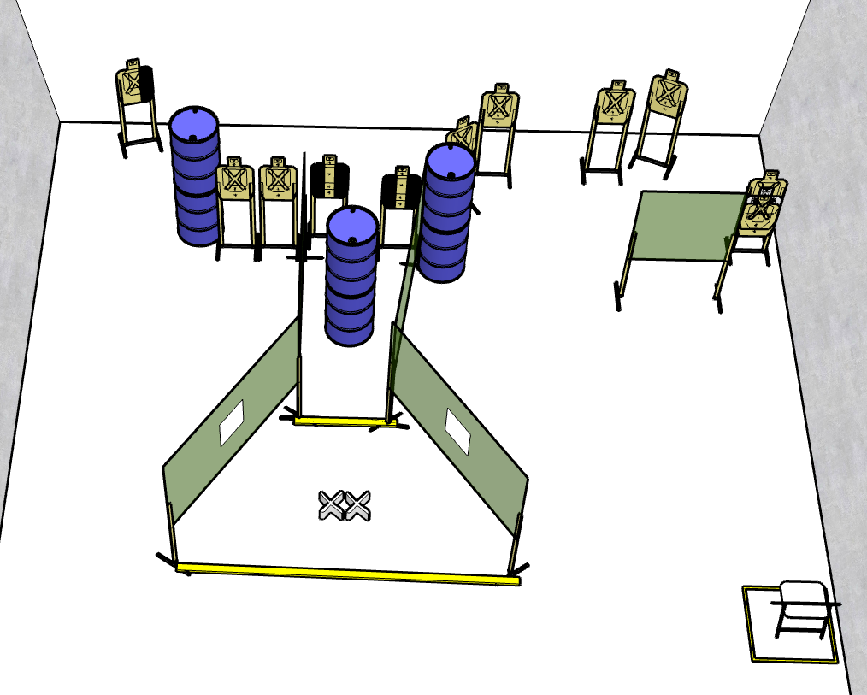

Stage 4 - Hey, guess what I did last night?
16 rounds, 80 points, Virginia count
There are 8 cardboard targets.
Starting with both feet on Red XXs.
Handgun is loaded and holstered, wrists below belt.
PCC is loaded, stock touching belt.
On the audible start signal, engage either T1-T4 or T5-T8 with only 2 rounds each, then make a mandatory reload and engage the remaining targets with only 2 rounds each.

Stage 5 - Hey, guess what I got in this bag?
6 rounds, 30 points, Comstock
There are 3 cardboard targets.
Starting seated in chair.
Handgun is loaded and holstered, wrists above head.
PCC is loaded, stock touching belt, strong hand wrist above head.
On the audible start signal, engage targets from within the shooting area.

